FINAL REPORT
Phase 2011-2013
Promoting Livelihood Security through Vegetable Growers Cooperative in three districts of Odisha,India
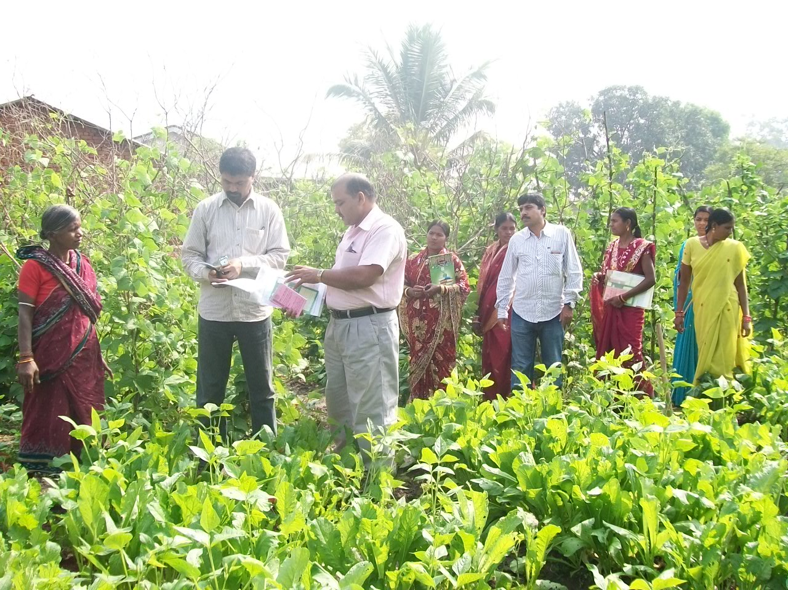
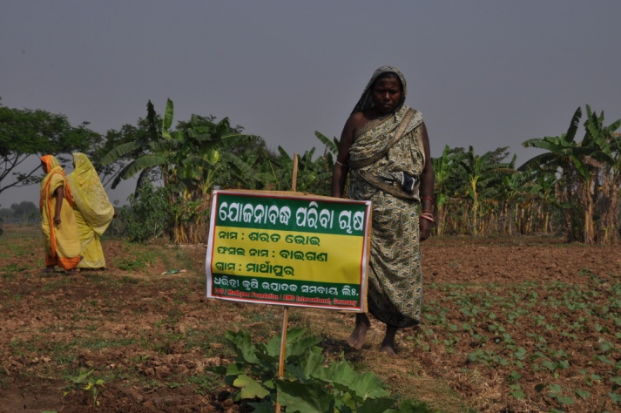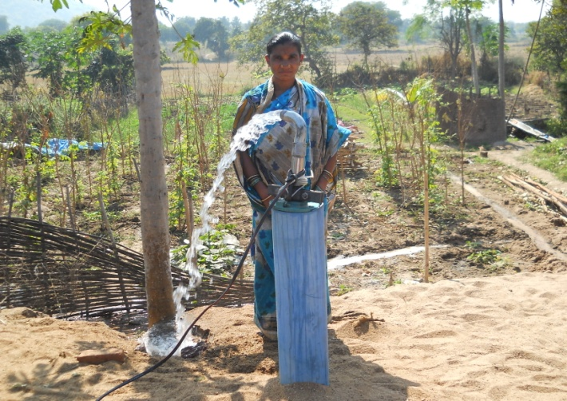
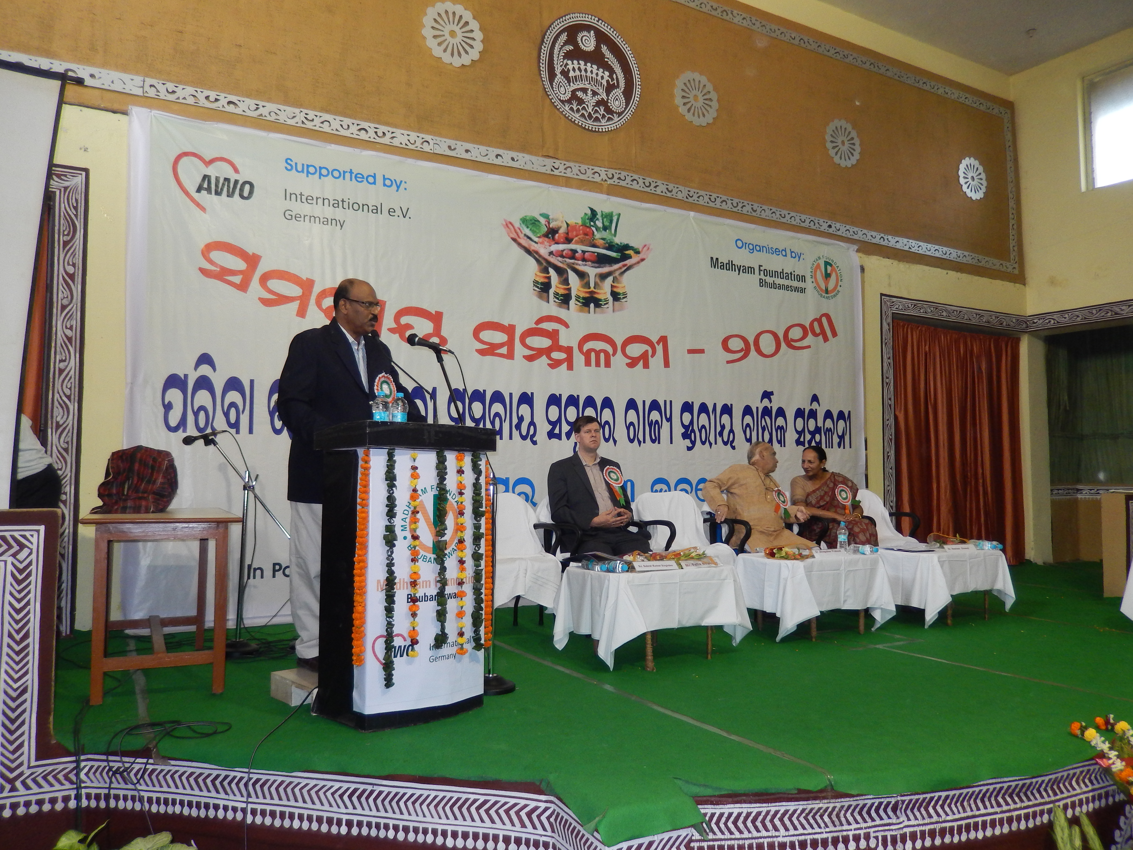
Supported by:
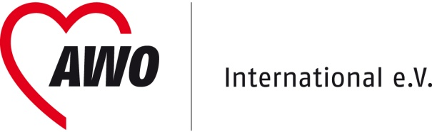 Germany
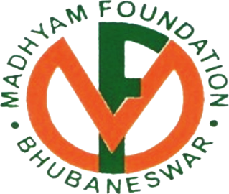
Submitted by:

Madhyam Foundation
N 3/ 202, Ekamrakanan Road.
IRC Village, Bhubaneswar- 751015
Odisha, INDIA.
Email:madhyamfoundation@gmail.com
Table of Contents
Item No | Particulars | Page No
 | Glossary or Acronyms | 4
1 | Brief Description of Political Development (Policies, Legal Framework, etc) and Change in the General Conditions in the field of Action of the Project 2011-2013 | 5
1.1 | Overall Political Developments on National & Regional level | 5-5
1.2 | Developments in Contexts of the targeted Issues (policies, facts, developments) | 5-5
1.3 | Risks & Developments that influenced project implementation and Results | 6-6
2 | Internal Changes (for e.g. staff, responsibility) within Organization as well as on Level of Implementing Partners / Structures 2011-2013 | 6
2.1 | General Organizational Management (incl. changes in communication / coordination mechanisms) | 6-6
2.2 | Management Changes & Fluctuation of Personnel (Partner & PNGOs) | 6-6
2.3 | Changes in context of Project Implementation & Project Design | 6-6
2.4 | Cooperation of Project with other Development Actors | 7-7
2.5 | Consideration of Crosscutting Issues | 7-7
3 | Contributions of other Stakeholders 2011-2013.. | 7-8
4 | Achieved Results and implemented Activities – Level of Accomplishment | 8-8
4.1 | Intended Impact versus achieved Results 2011-2013 | 8-8
4.2 | Achieved Results against BMZ Log Frame 2011-2013 | 8-17
4.3 | Implemented Activities against Plan 2011-2013 | 17-22
5 | Implementation Plan for the upcoming Year 2014… | 23-28
6 | Annexes | 29
6.1& 6.2 | 6.1 Achieved Results in 2013 against Partner Log Frame  6.2 Implemented activities in 2013 | 29-42
6.3 | Description of Outcome wise Photo Selection 2011-2013 | Being sent separately
6.4 | Other supporting Documents (for example IEC-Materials, etc.) 2011-2013 | Being sent separately

Glossary or Acronyms
ABBREVIATION | STANDS FOR | TRANSLATION/DESCRIPTION
 | (in National Language) | (in English)
CBO |  | Community Based Organization
CRP |  | Community Resource Person
CSP |  | Community Service Provider
DRCS |  | District Registrar of Cooperative Society
HH |  | House Hold
IRMA |  | Institute of Rural Management,Ananda
MFI |  | Micro Finance Institution
MGNREGA |  | Mahatma Gandhi National Rural Employment Guarantee Act
MKSP | Mahila Kisan Sashakti Karan Pariyojana | Women Framers Empowerment Project
NABARD |  | National Bank for Agriculture and Rural Development
NGO |  | Non Governmental Organization
NPK |  | Nitrogen(N)Prosperous(P)Potassium(K)
NRLM |  | National Rural Livelihood Mission
ODC |  | Organisiation for Development Coordination
PDS |  | Public Distribution System
PNGO |  | Partner Non-Governmental Organization
PRP |  | Para Professional
PUSPAC |  | Peoples United for Social Participation and Awareness Centre
SDS |  | Social Development Society
SLCFPO |  | State Level Committee of Farmers Producers Organisiation
SOMKS |  | Sishu ‘o’ Mahila Kalyan Samiti
TOT |  | Training of Trainer

I. Brief Description of Political Development (Policies, Legal Framework, etc.) and Changes in the General Conditions in the field of Action of the Project 2011-2013

1.1 Overall Political Developments on National & Regional level
During the project phase (2011-2013), some positive changes took place in our project areas, especially in the Maoist-affected district of Malkangiri.The Government of India, Government of Odisha, donor agencies and corporate houses showed pro-active initiatives in launching number of need based projects. All our five partner NGOs in the district were roped in to implement such projects due to their demonstrated impact through AWO supported project. Such a trend is likely to expand the scope of development engagement of our partner NGOs in the district
Due to frequent changes of the Registrar in District Registrar Cooperative society (DRCS) office the process of registration of new co-operatives by all the five partner NGOs of Malkangiri district were delayed although the PNGOs had submitted all the required documents for registration of second cooperatives in the month of July 2011. . The matter was brought to the notice of higher officials at the state level and then the cooperatives got the registration during Jan2012.
A positive policy change also happened during the reporting period. In November, National Bank for Agriculture and Rural Development launched a dedicated fund called Producer Organisation Development Fund to provide working capital loan and capacity building support to Producer organisations like the co-operatives promoted by us. This is a very significant development in view of the fact that till date no formal financial institutions were considering loan support to co-operatives.
In the year 2013 ,the State Government of Odisha passed an Ordinance on 6th June,2013 repealing the Odisha Self Help Co-operatives Act,2001 under which all the 20 vegetable growers co-operatives in the AWO supported project were registered. Such a drastic step was taken by the Government as number of Chit fund agencies( many of them registered as co-operatives under this Act) were found to have swindled deposits of small investors worth millions of rupees. Such a scam affected thousands of poor people across the State leading to road blockade, public bandhs, strikes and arrest of hundreds of people involved in the scam.
Madhyam Foundation organized number of consultations with its partner NGOs and it was decided to initiate necessary steps to change the bye-laws and elect a new Board of Directors at each co-operative, promoted under the project. One major implication of this change is that now all our co-operatives will become eligible to receive grant and soft loan from the Government which was not the case under the co-operative Act which was repealed. All our cooperatives applied to Appropriate authority for getting Registration certificate and 10 of them have already got the certificate under new Act. Rest of 10 Cooperatives are likely to get their certificates byFeb,2014.

1.2 Developments in contexts of the targeted issues (policies, facts, developments)

During this phase of Project, Govt of India launched a new nation-wide programme called Mahilakisahn Sashaktikaran Praiyojana( Empowerment of women farmers) under National Rural Livelihoods Mission(NRLM),recognizing contribution of women as farmers. It is heartening to note that Madhyam and its partner NGOs were sanctioned a project under this scheme to replicate AWO supported project in new areas..

1.3 Risks / Developments that influenced project implementation and results
In the year 2013,the State Government of Odisha passed an Ordinance on 6th June,2013 repealing the Odisha Self Help Co-operatives Act,2001 under which all the 20 vegetable growers co-operatives in the AWO supported project were registered . Such a step by the state Government created some sort of confusion among the co-operative members and Madhyam and its partner NGOs had organized series of meetings with the women members to clear such confusion

II. Internal Changes (for e.g. staff, responsibility) within Organization as well as on Level of Implementing Partners / Structures 2011-2013

2.1. General Organizational Management (incl. changes in communication / coordination mechanisms)
The rigour of MIS and financial management followed under AWO project is being followed in other projects of Madhyam.
2.2. Management Changes & Fluctuation of Personnel (Partner & PNGOs)

During the project period, maximum staff turn-over took place among 6 partner NGOs in Malkangiri and Kalahandi districts. Such turn over could be attributed to availability of better job opportunities in nearby districts. However, there was not a single staff turn over in DSS of Khurdha district. .At Madhyam level, there was only one turn over; Mr Ashok Kumar Rath, Project Co-ordinator of Madhyam Foundation left the project on 1st August,2012 to join the Odisha Community Tank Management project of Odisha Government as its Capacity Development Officer.

2.3. Changes in context of Project Implementation & Project Design
.
During the project period few new activites were added and few activities were dropped according to project need. The new activities added were: support for developing a 5 year strategic plan of Madhyam(2011), appointing and nurturing a carde of local Community Service providers in project area to provide on site handholding support for crop rleated issues of farmers( in 2012), Support of more numbers of water lifting pumps(20 pumps in 2012 and 60 pumps and delivery pipes in 2013) to increase coverage of vegetable field under critical irrigation., support for a short film on the project( 2012), a management development training for Livelihood Promoters(2012), District level co-ordination committee meeting by partner NGOs in Kalahandi and Malkangiri districts, purchase of simputers for co-operatives( 2012), a Reference manual for Community Service Providers( 2012), state level conference of Co-operative leaders( 2011 and 2012), support for outside state exposure visit by co-operative leaders(2012), and support for a mini exhibition during state level conference( 2013) The sales counters started by the co-operatives were dropped in 2013 as most of these counters did not add much value as envisaged at the start of the project.
2.4. Cooperation of Project with other Development Actors
Due to Annual district level interface meetings and state level conferences, rapport was built with officials of line departments of the state Government( at district as well as state level) and other financial institutions. The co-operative leaders got a platform to directly interact with these officials . Some selected Cooperative members got nominated to State level committee of Small Farmers Agri- Business Consortium, set up by Government of India.

2.5. Consideration of Crosscutting Issues
Please characterize how the project addressed crosscutting issues such as Gender Equality, Youth, Sustainability, etc.
Specific inputs were not designed under this project to directly address cross cutting issues like gender equality, youth, sustainability etc. However, the project interventions were instrumental in promoting gender equality in many ways. The status of women within their own family increased significantly as they have now an independent identity outside their family as a member of an organized entity( co-operative)They are now contributing to the household income and their access to family income and participation in household decision making process has also increased. Many co-operative members have now become members of various village level development committees.
Number of village youth have now become Community service Providers and are becoming instrumental in promoting sustainable agricultural practices in the villages .As far as issue of sustainability is concerned, the co-operative members have become confident in following a household level crop plan, preparation of organic manure and pesticides, seed treatment, seed preservation, marketing vegetables on their own and managing number of routine activities of their co-operatives.

3 . Contributions of other Stakeholders( 2011-2013).

Most of the fund mobilized by the Partner NGOs , Cooperatives as well as Madhyam is from three different sectors like Government, Formal Financial institutions and Corporate sector
1.Govt departments : Agriculture ,Horticulture ,Schedule Tribe & Schedule caste Development, water resources, Lift Irrigation ,Minor irrigation ,MGNREGA ( Mahatma Gandhi National Rural Employment Guarantee Act ) etc .
2. Financial Institutions: National Bank for Agriculture and rural Development (NABARD), national banks, Regional Rural banks, Micro Finance Institutions, Self help groups, Cooperatives
3. Corporate sector: Essar Foundation

During the project period, an amount of INR 2, 94, 97,443( Euro 3,68,718) were mobilized from abovementioned three sources to meet the working capital need and other requirements. In addition to this, an amount of INR 3,56,19,333( Euro 4,45,241) was also contributed by the members on their own towards working capital A year wise, source wise and break up of mobilization is given below

Year | Leverage from Government (Amount in INR) | Leverage from Corporate house (Amount in INR) | Mobilized & Contributed by PNGo (Amount In INR) | Community Contribution (Member/byCooperative HH )  (Amount in INR)
2011 | 13,80,950 | 0 | 44,67,900 | 63,35,409
2012 | 48,65,700 | 18,00,000 | 42,81,876 | 1,29,03,836
2013 | 40,93,367 | 10,06,000 | 76,01,650 | 1,63,80,088
Total | 1,03,40,017 | 28,06,000 | 1,63,51,426 | 3,56,19,333
Grand Total ( in three years ) |  |  |  | 6,51,16,776( Euro 8,13,959)

IV. Achieved Results and implemented Activities – Level of Accomplishment
4.1. Intended Impact versus achieved Results 2011-2013
The project successfully demonstrated that vegetable cultivation has the potential of enhancing livelihood security of small and marginal farmer households in the long run .Carefully designed interventions at pre-production, production, post-production and institution building of producers resulted in increased coverage of land under vegetable cultivation, reduced input cost due to promotion of organic manure and pesticides, value addition by way of sorting and grading, increased collective bargaining power vs the market forces by forming Producer co-operatives and finally enhanced household income by INR 30,000—40,000 per year per acre of land. Due to increased vegetable cultivation, consumption of vegetable by target households increased significantly thereby promoting nutritional security for all members of the households.
4.2. Achieved Results against BMZ Log Frame 2011-2013
- Outcome 1: Collective mechanism to ensure sustained increase in income gets established.
In the project this was well thought-out strategies were adopted right from pre-production stage till the institution building with a view to enhancing the production and productivity of vegetable growers and then nurturing their co-operatives to improve their bargaining power, enhance household income and inculcate elements of sustainability in the functioning of co-operatives. The training for Livelihood promoters on Management Development helped enhance their communication skill which got reflected in their engagement with the vegetable growers. In the pre-production stage, measures such as crop planning promotion of organic manure and pesticides, onsite handholding support by CSPs along with the agriculture consultant etc proved to be beneficial for growers. Many co-operatives have started preparing organic manures for sale to non-members. In the production stage, the training on seed selection, preservation and pest management for the growers has improved the quality of production. The seed bank at each Cooperative level has minimized the dependence of growers on hybrid seeds to a great extent and preservation of local seeds by farmers has increased substantially. .The water lifting pumps supported by AWO has proved very handy to address the critical irrigation. Increased use of organic manure has brought down the input cost substantially. .In the post-production stage, vegetables were graded and sorted at storage centres for sale to whole sales, vegetable sales counters were set up to cater to the retailers. Household level consumption of vegetables increased significantly adding to nutritional security of the growers’ households.
Due to all these measures, an upward trend could be noticed as far as all key indicators are concerned. Number of growers reached to 6333when projection was made to cover only for 5000 HH. An amount of 63,600(2011) 72,562 (2012) & 1,91,402 (2013) quintals of vegetables were produced which indicates increase in production of vegetables year to year and amount of INR,3,77,03,209( Euro 4,71,290)(2011),INR 11,48,48,843(Euro 14,35,610 )& INR 25,06,66,813(Euro 31,33,335)(2013) has been realized from vegetable sales by the growers during the project period which fetched a good and stable return to the vegetable growers.
.

Outcome: 2 Increased/enhanced nutrition (general health) status.

Production of vegetables through organic method increased significantly and on-site handholding by Community Service Providers proved very handy. Through training and regular interaction, the women members could understand the significance of consumption of organic vegetables in their daily diet. Before implementation of the project Household level vegetable consumption was only 150-200 gm per day per HH. Now this has been increased to the tune of 900gm-1kg per day per household which contributed in enhancing nutritional security of targeted households.
Outcome: 3: Effectively functioning organization gets established to influence the vegetable market at the relevant level

The vegetable growers co-operatives, promoted under the project, are the first such co-operatives, promoted in the whole state. The co-operatives are now functioning in a systematic manner by way of regular monthly meeting of the directors, mobilization of share capital, members fees and monthly saving, rotation of co-operative fund as loan among members and leveraging different schemes of the Government The orientation on software refreshed the LPs to manage the simputer system & Online software for the Cooperatives which built trust among the share holders and other stakeholders and promoted transparency. . Not only it helped the growers but also it helped the staff & reduced work load .The onsite orientation on software management really helped the Staff & Madhyam to get the MIS within no time.
All these point out to the empowerment of women members and their collective bargaining power .The board members as well as the CEOs of Cooperative refreshed on Business Development Plan and its implementation .The Board members of all cooperative oriented on book keeping of cooperative & on various aspects of cooperative management. Additional savings could be mobilized by all the members of Cooperative in their cooperative in addition to savings made by them in other place (Bank, SHG ) an amount of INR 27,72,039(Euro 34,650) savings could be mobilised during the project period in their Cooperative. The fund base of all co-operatives within this short span( out of 20 cooperative 10 cooperatives registered during 2010 & 10 cooperatives got registration during 2011) reached to INR Rs 51,81,568(Euro 64,769 ). The fund base of all the cooperatives reached to this figure because all the cooperative could generate revenue from the service provided by them to their growers like sale of organic manure, margin of vegetable sales, Margin of seed selling through seed bank, Service charges collected from water lifting pumps bore wells etc. Prior to the project, the women farmers used to sell their produces only in weekly markets. With setting up of storage centres, aggregation of vegetable could be done and wholesale buyers, Institutional buyers were contacted who lifted vegetables from the storage centres. Some co-operatives also purchased vans for mobile marketing at strategic locations. The Zero energy cold chambers ,set up at storage points and selected households helped in reducing distress sale as members could store the balance produces for next weekly markets. Thus, by becoming members of co-operatives, the women farmers were able to diversify their marketing channels.

