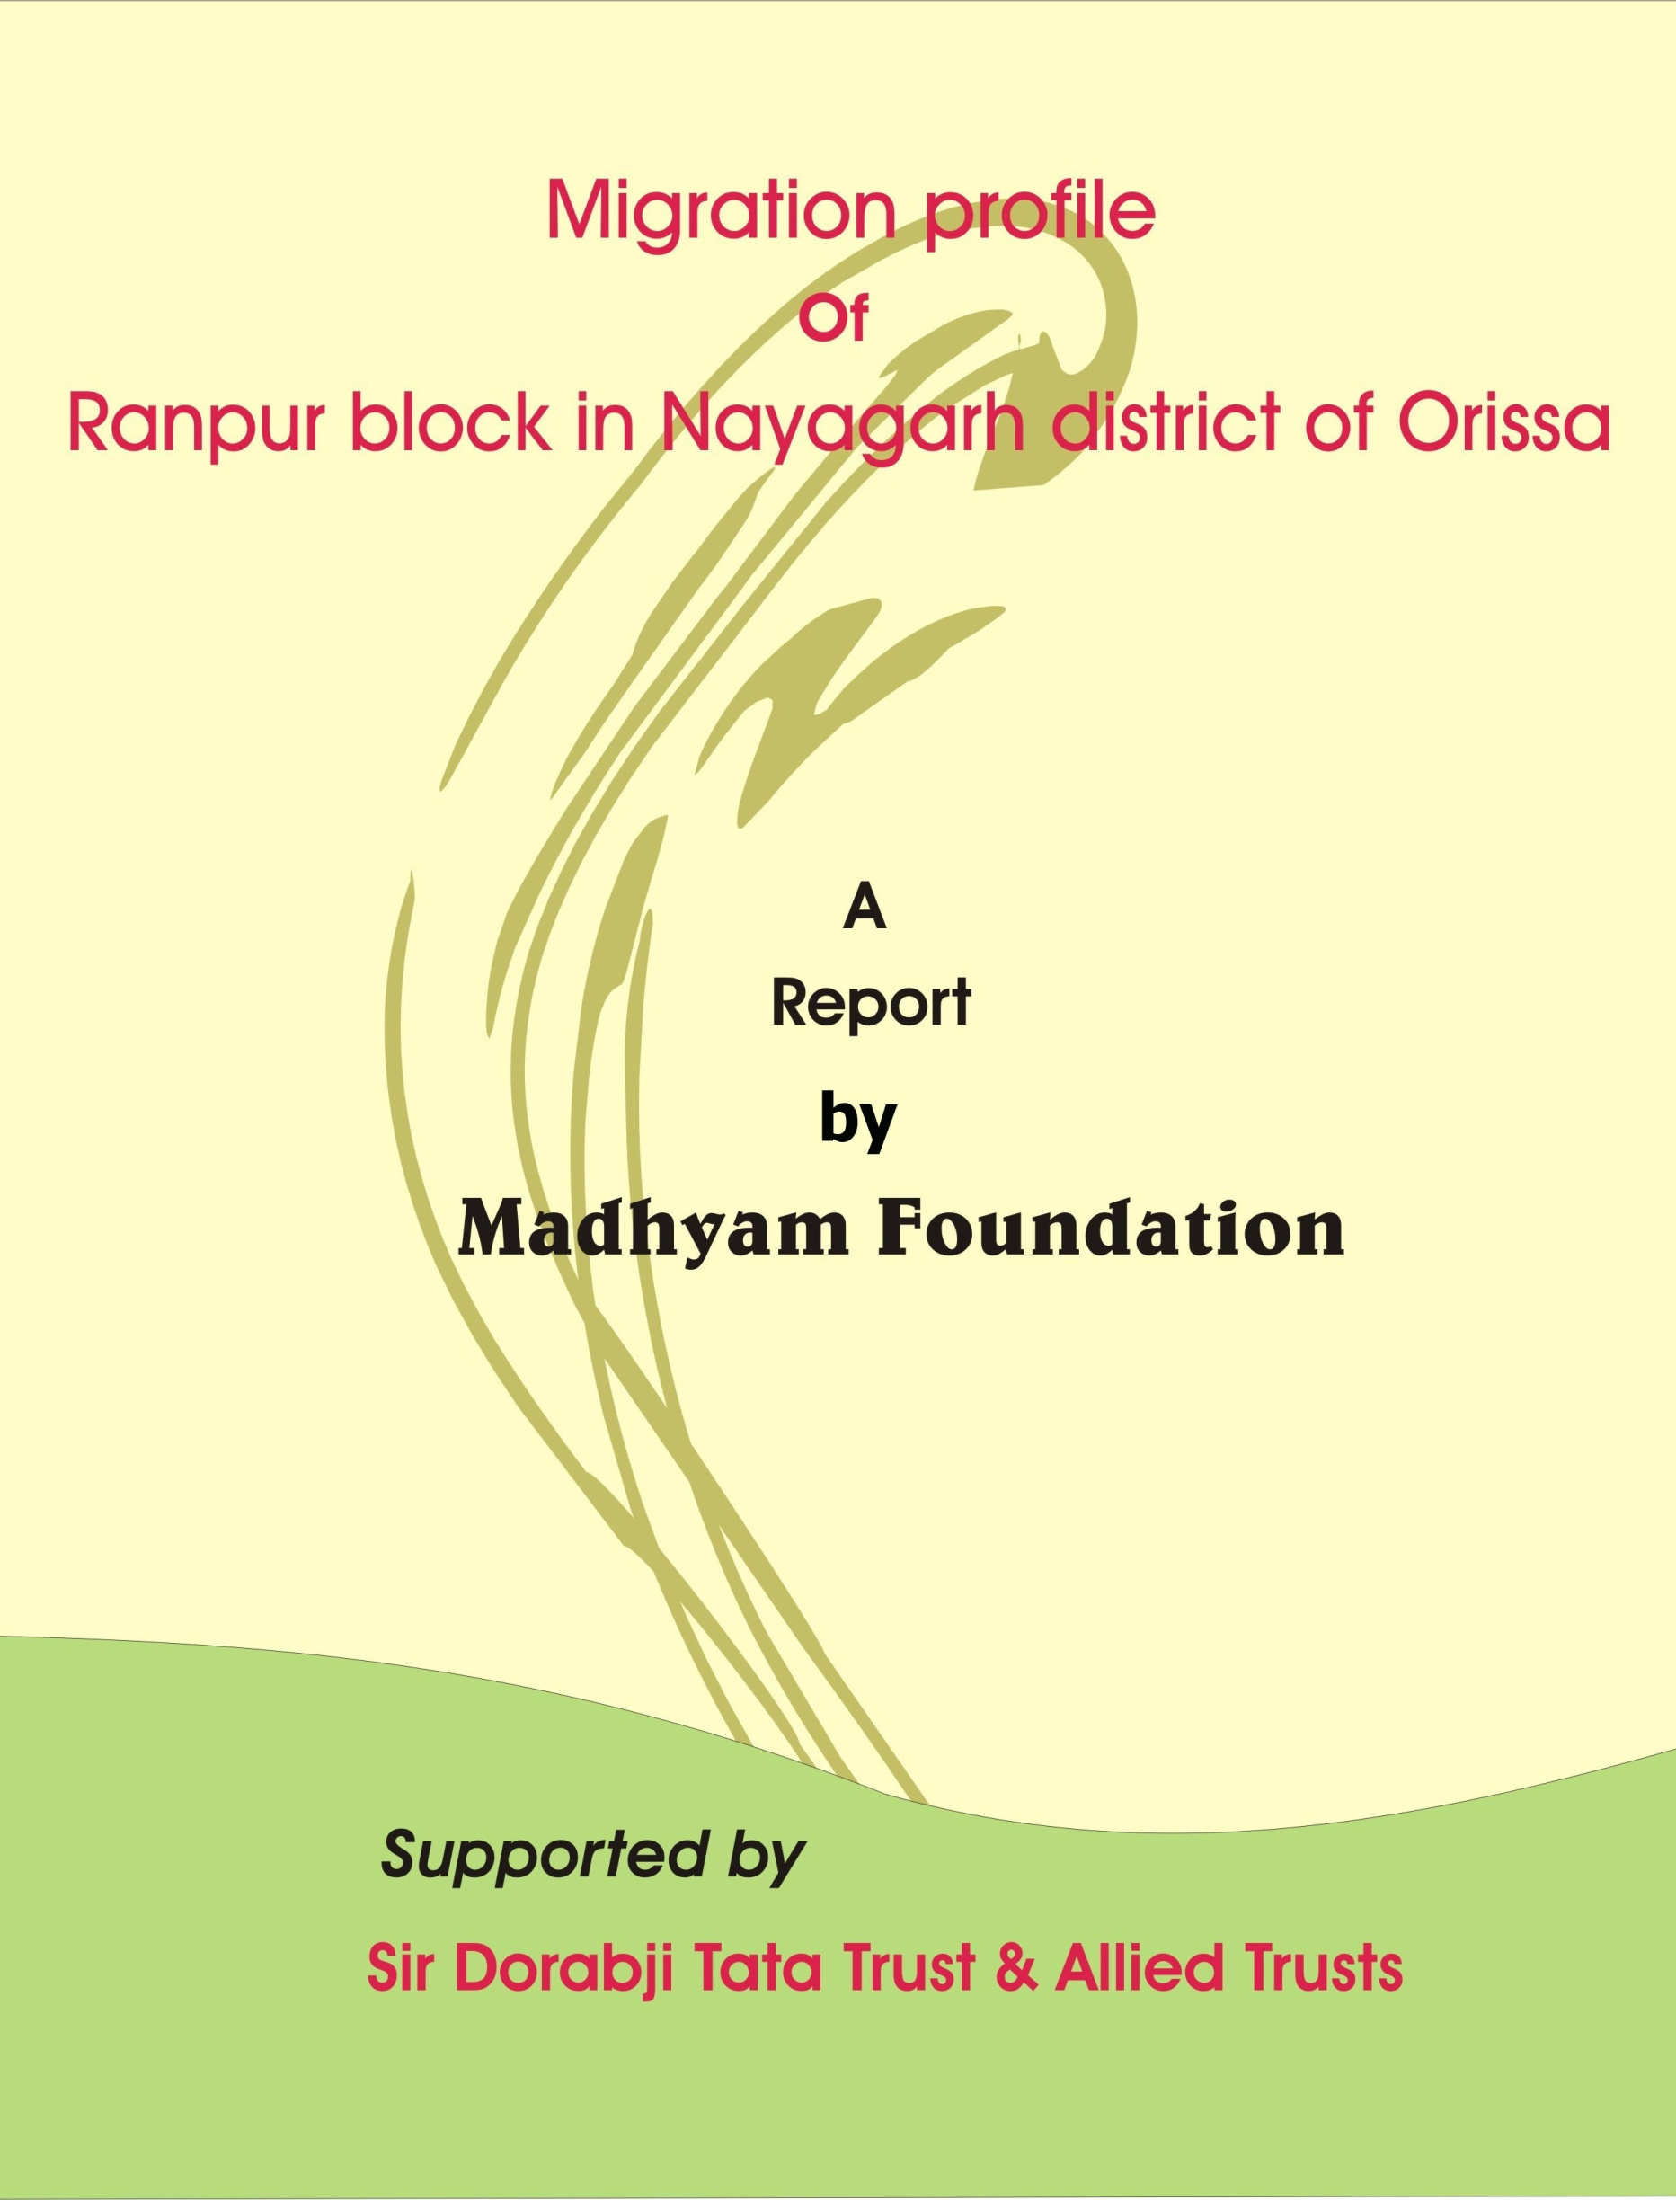

Migration in India is not new and historical accounts show that people have moved in search of work, in responses to environmental shocks and stresses, to escape religious persecution and political conflict. However improved communications, transport networks, conflicts over natural resources and new economic opportunities have created unprecedented levels of mobility. Although significant in recent years, growth in India characterized by industry in developed states such on Gujarat, Maharashtra and Punjab is drawing labour from agriculturally backward and poor regions such as eastern Uttar Pradesh, Bihar, southern Madhya Pradesh, western Orissa and southern Rajasthan. High productivity agricultural areas (Green revolution areas) continue to be important destinations, but rural-urban migration is the fastest growing type of migration as more migrants choose to work in better paying non-farm occupations in urban areas and industrial zones. Labour mobility has grown and will probably continue to grow.
Migrant labour makes enormous contributions to the Indian economy through major sectors such as construction, textiles, small industries, brick making , stone quarries, mines, fish and prawn processing and hospitality services. But migrants remain on the periphery of the society with few citizen rights and no political voice in shaping decisions that impact their lives. The bulk of the migrant workforce in India has little or no education. In fact, migrants are poorly endowed all-round : they come from poor families where access to physical, financial and human capital is limited and where prospects for improving living standards are constrained by their inferior social and political status.
Historically, disadvantaged communities such as scheduled castes, scheduled tribes and other backward castes are heavily represented in migration. Poor migrants are absorbed in informal sector jobs, much maligned for being insecure, poorly paid and unproductive but offering the only option for labourers to improve their capabilities. According to the National census for 2001, 30% of the population or 307 million were migrants. Inter-state migration has grown by 53.6%. Uttar Pradesh and Bihar were the two states with the largest net outmigration.
Migration in Orissa:
Migration of poor people, specially the scheduled castes, had started during British rule when people had gone to Assam to work in tea gardens of British employers in India during late 19th and first half of 20th century. However, that was one type of forced migration made by the British rulers and majority of such migrants did not return to their native place. During the early independence years, Orissa had witnessed some occasional and casual migration. But the intensity and scale of migration from Orissa had started during early 1980s.
Poverty and migration have always been inter-related in Orissa. Seasonal migration has become an important livelihood strategy for many Oriyas. Lakhs of people migrate to other states for working as wage labourers. A clear trend could be seen in migration from southern Orissa, western Orissa and coastal Orissa. In case of western Orissa, migrants are mainly unskilled labour who are forced to migrate due to food insecurity, poverty & economic compulsion. But migrants from southern Orissa & coastal Orissa are often skilled or semi-skilled people who are rather drawn by the pull factors of migration in search of extra money for investment purposes back home.
Migration profile of Ranpur block in Nayagarh district of Orissa:
Nayagarh district was carved as a separate district in 1992 out of the then undivided Puri district. The district occupies a total of 3491 square kilometer out of which 49.06% are covered by forest. Bio-geographically the district comes under east coast province and eco-region wise it is under eastern highlands moist deciduous forests. Nayagarah is located towards the west of Puri district surrounded by Cuttack district in the North, Kandhamal in the West, Ganjam in the South and Khurdha district in the East. The district is situated in the hilly ranges in the west and its North Eastern part has formed a small well cultivated fertile valleys intersected by smaller streams. It is situated at higher altitude and above the flood level. The river Mahanadi flows in the eastern boundary.

The district accounts for 2.5% of state’s territory and shares 2.35% of the State population. The density of population in this district is 222 persons per sq.km as against 236 persons in the state. The district consist 1695 villages, covering 8 Blocks, 4 Tahasils and One subdivision. As per 2001 census, the Scheduled caste and Scheduled Tribe population consists 14% and 5.9% respectively. The literacy rate of the district is 70.52 against the state average of 63.08% and sex-ratio is 938 against the state average 972.The decennial growth rate as per 1991-2001 census was 10.46% as against 16.25% of the state.
Geographical and Demographic Profile of Ranpur:
Out of the eight CD blocks in the district, Ranpur block is the most backward which includes the plateau and hillocks and most of the reserve and protected forest areas. Ranpur is having total geographical area of 367.83 Sq.kms, 235 revenue villages and 30,449 households. According to 2001 census, the total population of Ranpur Block is 150238 comprising of 76044 male population and 74194 female population. The share of Scheduled caste and Scheduled Tribe population are 8.85% and 5.4% respectively. The climate of the district carries a high summer temperature and low winter temperature, having monsoon break during month of June and July. Average annual rainfall of the Block is 159.36 mm. The literacy rate of the Block is 74.51%, comprising of male literacy rate (85.18%) and female literacy rate (63.79%), but the literacy rate is very low in the case of tribal population.
Total Population |  |  | SC Population |  |  | ST Population
Male | Female | Total | Male | Female | Total | Male | Female | Total
76044 | 74194 | 150238 | 6296 | 6995 | 13291 | 4025 | 4098 | 8123
Source: Census of India 2001
Land utilization pattern of Ranpur Block
The land utilization pattern of the Ranpur Block denotes that share of net shown area is more, followed by land utilized for non agricultural uses, trees and groves, pastures and grazing land, forests and others. The major bottleneck is the very minimum irrigation potential, only 5861 hector of 18336 of total area sown .The share of irrigated land is 32%,which is only in the form of minor and lift irrigation, severely jeopardizing the development of agriculture. The land utilization pattern of Ranpur is shown in the graph below:

Source: District Statistical Handbook Nayagarh, 2007.
Agriculture is the primary source of income for most of the households in the Block. Paddy cultivation is the dominant agricultural activity followed by others mainly maize, black gram, til, groundnut, potato, jute and sugarcane. The productivity from agriculture is very meager because of small landholding, lack of irrigation and other supply chain problems like lack of farm mechanization, insufficient use of fertilizers, pesticides and insecticides, storage and marketing problems and poor rural infrastructure. Next to agriculture is the livestock rearing, which is also a significant occupation for the people, but the returns from this sector are also very discouraging. Besides these the other sectors in occupation classification are not that much remunerative to provide a decent income for the households of the block.

Gram Panchayat-wise status of migration in Ranpur Block
G.P Name | Total Households | Total Migrant Households | Percent | Total Nos. of Migrants
Balabhadrapur | 1423 | 492 | 34.57 | 521
Bandhamunda | 537 | 228 | 42.46 | 228
Baunsgada | 998 | 450 | 45.09 | 511
Brajarajpur | 949 | 382 | 40.25 | 475
Brundabanpur | 580 | 332 | 57.24 | 347
Champagada | 534 | 257 | 48.13 | 268
Champapedi | 846 | 462 | 54.61 | 463
Chandapur | 564 | 155 | 27.48 | 156
Damasahi | 1021 | 295 | 28.89 | 311
Darpanarayanapur | 1013 | 353 | 34.85 | 376
Gopalpur | 1104 | 369 | 33.42 | 370
Gourangpur | 748 | 482 | 64.44 | 517
Jankia | 514 | 315 | 61.28 | 324
Kandapada | 959 | 558 | 58.19 | 558
Kandha Nayagarh | 631 | 249 | 39.46 | 254
Kasanda | 733 | 435 | 59.35 | 547
Kerandatangi | 1018 | 367 | 36.05 | 373
Khairapalli | 990 | 515 | 52.02 | 680
Khatia | 820 | 460 | 56.10 | 506
Kulasar | 535 | 225 | 42.06 | 330
Lodhachua | 1100 | 550 | 50.00 | 682
Mahatpalla | 805 | 457 | 56.77 | 471
Majhiakhanda | 1072 | 503 | 46.92 | 529
Mayurajhalia | 1270 | 498 | 39.21 | 506
Narasinghpur | 946 | 297 | 31.40 | 328
Narendrapur | 741 | 214 | 28.88 | 280
Patia | 986 | 644 | 65.31 | 648
Pimpal | 395 | 276 | 69.87 | 432
Raipada | 497 | 223 | 44.87 | 229
Raj Ranpur | 2040 | 325 | 15.93 | 353
Rajsunakhala | 2295 | 275 | 11.98 | 285
Rankadeuli | 857 | 252 | 29.40 | 289
Surukabadi | 505 | 287 | 56.83 | 414
Talakani | 423 | 245 | 57.92 | 331
Total | 30449 | 12427 | 40.81 | 13892

As evident from the above table, 40.81% households of the entire Ranpur block report seasonal migration of at least one or more than one member from each household. Out of the total 34 gram panchayats, Pimpal GP records the highest( 69.87%) migrant households while Rajsunakhala GP reports the lowest(11.98%) number of migrant households. It is a matter of concern to note that four GPs( Gourangpur, Jankia, Patia and Pimpal) have reported over 60% migration while additional ten GPs( Brundabanpur, Champapedi,Karadapalli,Kasanda,Khairpalli,Khatia, Kandapada,Mahatpalla,Lodhachua and Talakani) have recorded migrant households between 50% and 60%.
Socio-economic profile of Migrants

All the migrant households of the block belong to lower strata of the society. The largest percentages( 79%) are from other backward castes(OBC), followed by scheduled castes(9%), Scheduled tribes(6%), General castes(5%) and Minority(1%) respectively.
.
The age-wise classification of migrants reveal that maximum migration takes place in the age group of 21-35 years(58%), followed by migrants in the age group of 36-50 years(27%)It is a matter of concern that children and youth in the age group of 14-20 years(11%) also migrate in search of work when they should be in schools and colleges. Out of the total 13,892 migrants , 65% migrants are married and rest 35% are unmarried.

Level of education | Percent
Illiterate | 4%
Up to primary | 31.4%
Up to middle | 45.3%
Matriculation | 10.3%
Intermediate | 6.1%
Graduate | 2.9%
Total | 100%

The level of education of migrants show a mixed trend. The percentage of illiterates is pretty low in comparison to migrants from Western Orissa and Southern Orissa where it is generally over 40%.This is due to relatively higher literacy rate of the Block. However, majority of migrants are school drop-outs.

Causes of migration-
From the survey it was found that most of the time the causes of migration are due to “Push factor” leading to forced migration. Wide spread un employment, unproductive agriculture, prevailing low wage structure, lack of opportunity in the non farm sector, lack of enough work under MGNREGS and financial insecurity were considered as the main reasons for migration. Majority of migrants are locked in debt- migration cycle, where earning from migration is used to repay debts incurred at home. The other reason is purely voluntary in nature because of limited choices available for subsistence.

33.9% of people migrate 2 times a year. 5.2% of people migrate seasonally and 60.9% of people migrate through out the year.

Duration of migration from the Block varies between 3 months and 12 months in a year. However, maximum people( 53%) migrate for 10 months in a year followed by people migrating for 8 months(21.8%) in a year. Even, 7.6% of migrants migrate for the whole year. Such a trend clearly establishes as to how migration has become an important livelihood strategy for the people in the Block

Mode of recruitment-

Mode of recruiting migrants from the block clearly shows that role of agents and contractors recruiting labour has drastically reduced over the years .Due to regular migration over the years, the migrants have established their own network and contacts to migrate in search of work. Only .9% of migrants go through agents while 1.1% of migrants migrate through contractors. Some of the migrants go through their friends (. 1%) and relatives(.1%)Majority (97.8%) of migrants prefer to go on their own.
Destinations of migrants
Mapping of destinations for migrants reveal that they cross district boundaries, state boundaries and some times national boundaries . The destination data from the block shows that inter state migration is the most preferred form of migration(67.86%) followed by intra-state migration(31.73%) and a negligible percentage of migration( .41%) to other countries.
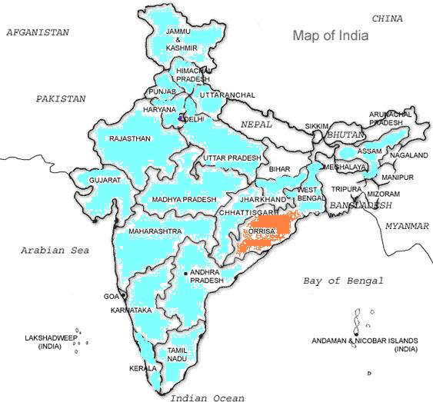

Inter-state migration- The composition of inter-state migration reveals that migrants move to each nook and corner of the country though one can notice a monopoly of certain destinations. These overall distribution pattern to different parts of the country defies any logic. The top four destinations are Kerala (16%),Gujarat(13%), Jammu and Kashmir( 9%) and Maharashtra (8%). The preference for this location –specific migration can be partly attributed to the fact that unlike in western Orissa and parts of coastal Orissa, the practice of recruiting migrants by contractors/Agents has been declining in Ranpur block. As evident from the data, the four states of south India jointly account for the highest( 26%) number of migrants from the block. Apart from the abovementioned four top destinations, other destination states are Andhra Pradesh, Assam, Chhattisgarh, Delhi, Haryana, Himachal Pradesh, Jharkhand, Madhya Pradesh, Punjab, Karnataka, Rajasthan, Tamilnadu, Uttar Pradesh, Uttaranchal, West Bengal, Puduchery and Daman and Diu.
It may appear very peculiar that Kerala has emerged as a preferred destination for most of the migrants .In most urban areas of Kerala, sundry jobs that require hard labour are increasingly being taken over by “replacement labour”. Kerala economy is heavily dependent on remittances made by nearly 22 lakhs of its people working in Gulf countries and their place at home is steadily being taken over by labourers from other states .Migrants come with the construction boom with the big time builders and mega IT, airport road, rail and port projects and the ply wood factories. They found that wages were high, working condition much better & there was no body to do those jobs surprisingly in a state with the largest number of (educated) unemployed.
Perumbavoor, 35 km from Kochi in central Kerala is dominated by veneer & plywood units, saw mills and large number of small industrial units. There is a cinema hall in Perumbavoor that screens only oriya movies .Even the advertisements are in oriya language. The Industrial belt in Palakkad, jewelry, sweet shops in Thrissur, agriculture tracts in Wayanad & Idukki are some other top destinations for migrants from other states including Orissa.

The intra-state data on migration reveals that migrants go to work in as many as 20 districts( out of 30 districts) of the state but the state capital, Bhubaneswar city emerge as the most preferred location for 59.39% of the internal migrants As far as migration to outside countries is concerned, people go to countries such as Baharin, Bhutan,Dubai,Iraq,Kuwait, Muscat, Nepal, Oman, South Africa and Saudi Arab. Out of 13,892 migrants from the block, only 56 persons were found to have gone to the abovementioned countries.
Occupational pattern of migrants

The employment and occupational profile of migrants reveals that people are engaged in all sectors like primary, secondary and tertiary. Occupation-wise, construction labour (40.05%) emerges as the dominant one followed by spinning mill workers (12.84%), head loaders (8.62%) and masons (4.85%). Rest of the migrants were found to be working as drivers, carpenters, plumbers painters, wielders in iron factory, security guards, waiters in hotels, unskilled labourers in cement factory, plywood factory, sawmills, garment factories etc. Relatively more qualified migrants (intermediates and graduates) were found to be working in supervisory positions.
Income pattern of migrants
The income profile of migrants reveals an uneven distribution which ranges between Rs. 2,000 and Rs. 20,000 per month. The classification of income distribution reveals that maximum number of migrants (54%) earn Rs. 5,000 per month, followed by Rs. 4,000 (32.2%) and Rs. 3,000 (7.4%). Only 4.7% of migrants were reported to be earning Rs. 6,000 per month. Monthly earning by migrants ranging between Rs. 6,000 and Rs. 20,000 are very negligible
Money remittance by Migrants-
A high percentage of migrants( 99.8%) send money back home to their families.Remittance by migrants varies between Rs500 and Rs 5,000 per month. But majority of migrants(86.5%) send Rs 2000 per month followed by 11.3% of migrants who send Rs 1000 per month to their home. This trend clearly shows the dependence of families on remittances by migrants.
Money remittance from Kerala
The State Bank of India branch, located near the Raj Bhavan in Thiruvananthpuram has to open additional cash counters on Sundays to cater to 300 – 400 migrants who come on that day. They come from various worksites in the city to send their weekly savings home – in West Bengal, Orissa, Bihar, Jharkhand, Chhattisgarh etc. The money is deposited in a relative ‘s or friend’s account so that it can be withdrawn without delay. According to Mr. Anthony Kuriakose, an official of the bank for several years, such migrant labour remittances have ranged from Rs. 2,000 to Rs. 10,000 per head. Migrant labour remittances through this branch is nearly Rs. 15 lakh every Sunday.
Source: Migrant labour: Invisible people by Mr. R. Krishnakumar

Problems faced at destinations-
The migrants face a host of problems at destinations.
Sl.# | Problems encountered | Reported by Migrants
1 | Overcrowded accommodation and unhygienic sanitation facilities | 96.1%
2 | Food | 94.6%
3 | Payment of less wages and no wages during illness | 13.2%
4 | Illness | 23.6%
5 | Communicating with families back home | 2.8%
As evident from the above table, the main problems faced by the migrants pertain to basic services (shelter, sanitation , food and health services). Quite surprisingly, wage related problems were reported by relatively lower percentage (13.2%) of migrants.
----------------------------------------------------xxx--------------------------------------------

Annexure: Survey Form
Personal information of migrant labourers.
(Information collected by “Shramik Sahayata O Soochana Kendra”
Madhyam Foundation, Bhubaneswar)

INFORAMTION
Date:
Village name: Panchyat name:
Village code: Panchayat code:
House code:
- Family details

- Name of the head of the family :
- Category : (ST, SC, OBC, General, Minority)
Total family members :
Male >14 :
Female>14 :
- Is any of your family member a migrant? : (Yes, No)
If yes, give detail information of them.
Sl# | Name | Age | Educational qualification | Marital status
1 |  |  |  | Married | Unmarried
2 |  |  |  | Married | Unmarried
3 |  |  |  | Married | Unmarried
- Detail information of migrant labourers.
- How many times a year do they migrate?
Day | Month | Year
Period ------------ to ------------------
Self | Friend | Contractor | Agent | Sub-agent
- How do they migrate?
Name:
Address:
- Where do they migrate?
Inside the district/Inside the state/ Other state/ Foreign country( Please specify)
- What work do they undertake at destination?
Please specify the work
1…………………………2………………………3………………………. 4………………………….
e. Do they get advance from the contractor?
if yes, how much (In rupees-----)
f. How much money a migrant labourer earn during the migration period?
Monthly Yearly
Yes | No
g. Does the migrant send money to his home
If yes, then how much ?
Monthly | Yearly
h. What type of difficulties a migrant labourer face during his stay at destination?
1. Health related
2. Food related
3. Stay related
4. Wage related
5. Travel related
Yes | No
i. Does the migrant labourer get affected by any disease?
If yes, please specify the disease.
Name of the diseases
1…………….………. 2…………………… 3……………………
Yes | No
j. Has the migrants labourer registered himself with district labour office?

Information given by Information collected by

Name: Name:

Signature: Signature:

